Analysis
Description of the problem
In Formula 1, strategic decisions can have a decisive impact on race outcomes. The aim of this project is to develop a data-driven simulator to simply determine the optimal pit stop strategy that minimises total race time of one single car. This simulator is designed to operate in two modes: a deterministic mode, where the user defines the placement of race events such as safety cars, VSCs (virtual safety cars), and weather events, and a probabilistic Monte Carlo mode, where random events are placed to introduce uncertainty. By analysing different strategies under these varying conditions, the simulation engine tries to find out approaches are the fastest or the most robust, while keeping the model simple by focusing only on core decision variables
The target audience for this project is hobbyists who are interested in exploring Formula 1 race strategies with data-driven simulations. It allows for analysis and comparison of pit stop strategies under both deterministic conditions, where race events are predefined, and probabilistic conditions, where race events occur randomly. By focusing on core decision variables, the simulator allows users to experiment with many “what-if” scenarios and understand the impact of several different layered parameters on overall race pace and performance.
Analysis of similar systems
After doing some initial investigation, I realised that many simulators described as “F1 strategy simulators” are not focused directly on physically modelling race strategies with computational methods, but instead emphasise on team management, resource allocation, and other gameplay elements. Such systems often simplify key factors such as lap modelling (the main physics element) and prioritise user interaction over realistic simulation (it is a game rather than a simulator). However, a small number of programs are designed specifically to carry out simulations with data-driven approaches, using variables such as pit stop loss, tyre wear, track evolution, etc. These are the more technical simulators that evaluate optimal strategies by modelling performance one lap at a time and comparing total race times under varying conditions. This shows that there is a distinction between the two types of systems, where one is entertainment focused and the other is an analysis tool. This project falls within the second category, as it aims to develop a simplified yet realistic computational model that focuses on core strategic decision-making. Here is a brief description of two similar systems that already exist:
1) Stratsim
Stratsim is a Formula 1 strategy simulator that allows users to configure the main race variables such as track selection, weather conditions, driver and team parameters, and tyre compounds. It uses a physics-based approach, to model lap times and tyre degradation and produce a realistic race simulation.
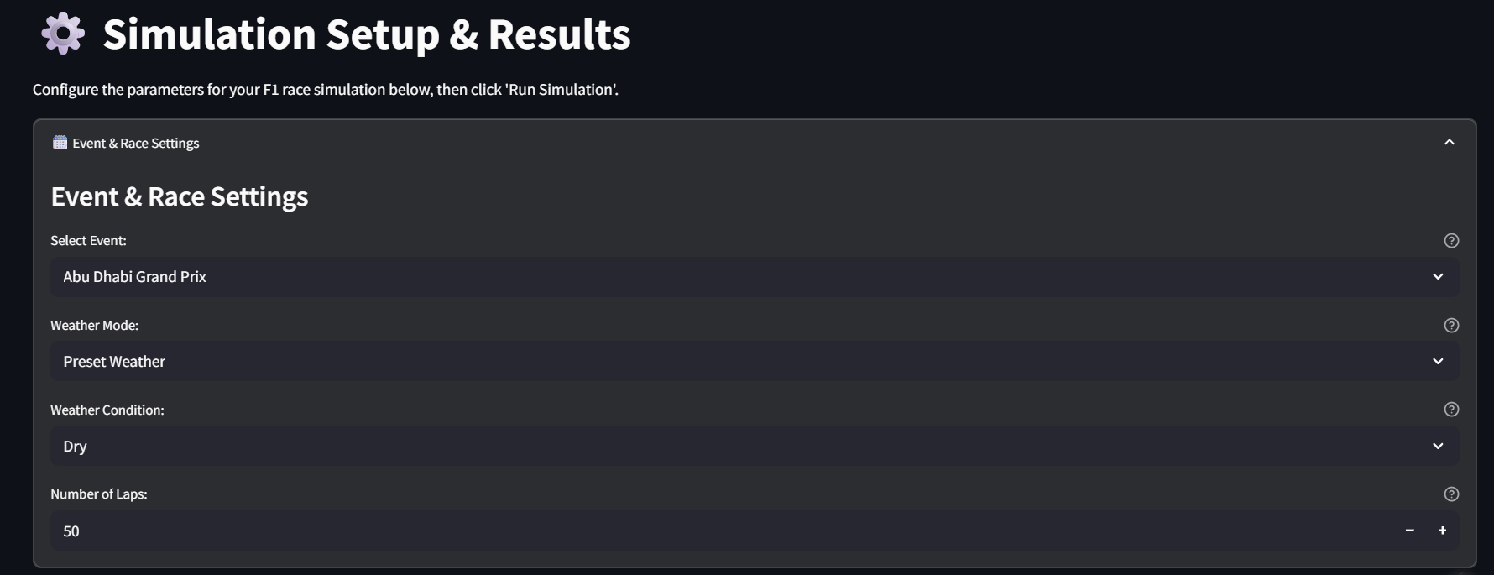
An interesting thing to note here is that the user has a choice between preset weather (presumably normal weather) or live weather, where live weather data will be fetched from the location of the circuit at the start of the simulation. The simulator then allows to user to select up to 20 drivers, where the input is the driver, team, starting position and starting tyre compound.
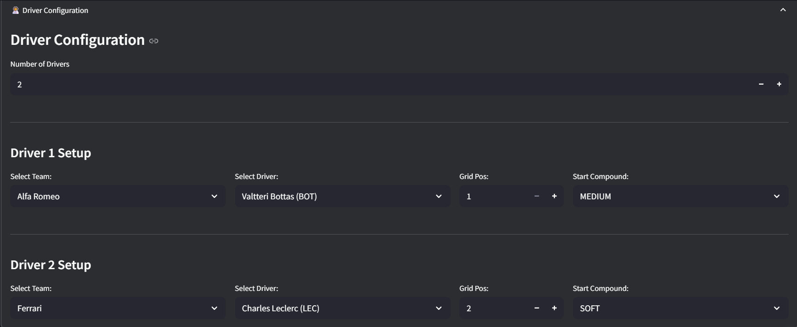
Once the simulation is completed, it shows a detailed race analysis for each driver chosen, including parameters such as lap times, tire wear, degradation, and grip level (all the graphs show parameters against each lap)
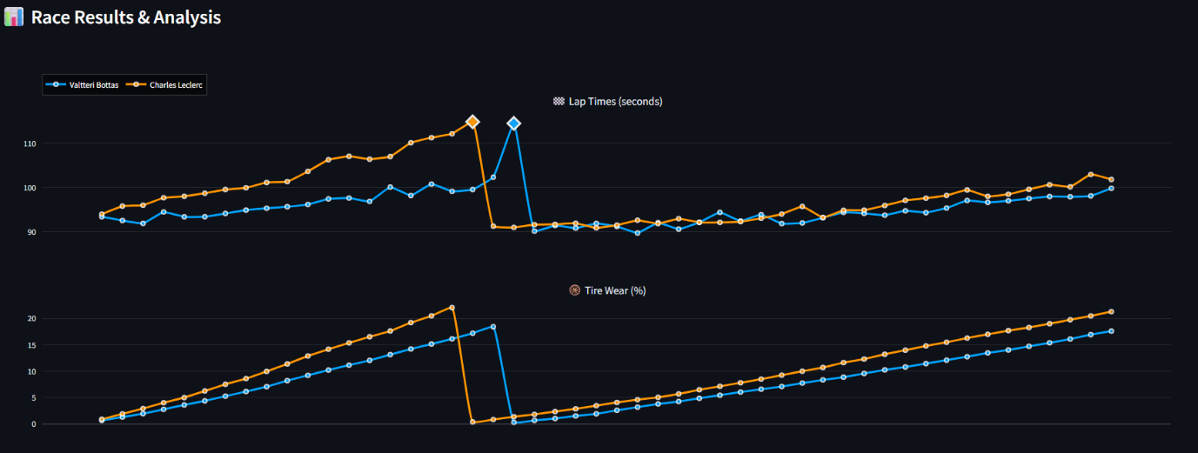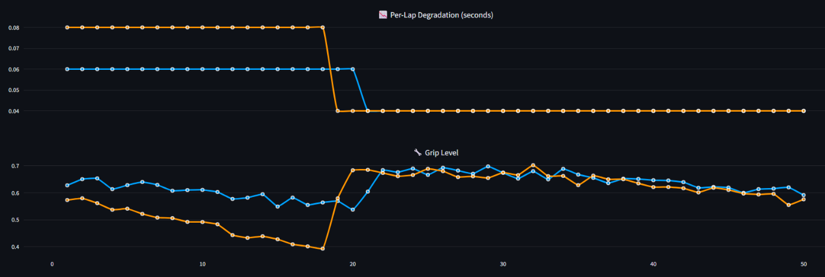
In this example, I used 2 drivers to demonstrate the simulator’s ability to produce such graphs, but each graph can go up to 20 unique coloured lines (that correspond to 20 drivers)
Positives:
- Ability to simulate multiple drivers/cars at once (on all 24 tracks)
- Ability to use trackside weather in real time
- Good analysis structure with 4 graphs illustrating the variation of core variables throughout the span of the race
Negatives:
- There are no random weather or random events
(the user can select a “variable weather” option, but this only generates a random number (amount of rain measured in mm/hr) which is used throughout the race)
2) The F1 Race Sim
The F1 Race Sim is another such strategy simulator that allows users to create and simulate custom strategies in custom race simulations. It also uses a physics-based approach just like the previous example, while accounting for input variables such as weather conditions, driver style, available tyre compounds, and pit stop laps (the laps on which the driver pits).
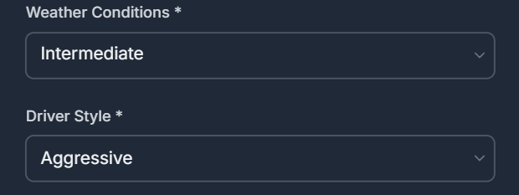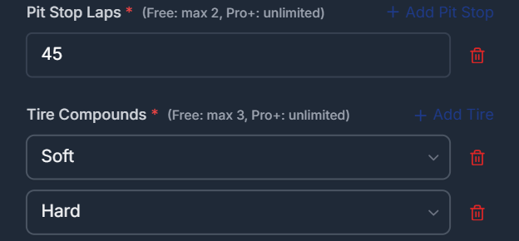
The user then gets to select the track of their choice, where they can see the different stats of the track such as circuit length, historical lap record, the total number of laps, and weather sensitivity.
The user can then see more race relevant stats such as humidity, wind speed, rain probability, and grip level.
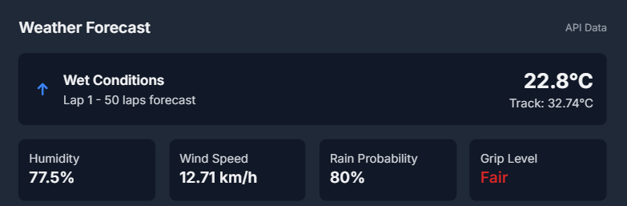
The 4 main weather forecast variables cannot be modified by the user. This is because the weather data is retrieved via external APIs and is updated close to in real-time through periodic polling (repeatedly requesting data at some fixed interval).
(close to but not perfectly in real time as caching layers introduce additional latency along with the polling and updating)
The rain probability percentage is used only when the weather conditions is set to “intermediate”, and not “dry” or “wet” (since it would be constant).
It also shows weather data for each lap before the simulation is even started (assuming that the simulation will be carried out immediately).
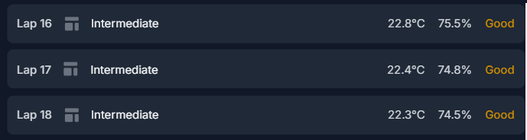
Once the simulation has been carried out, the results and analysis are shown. The lap time and tyre wear % are shown on the same graph (against laps)
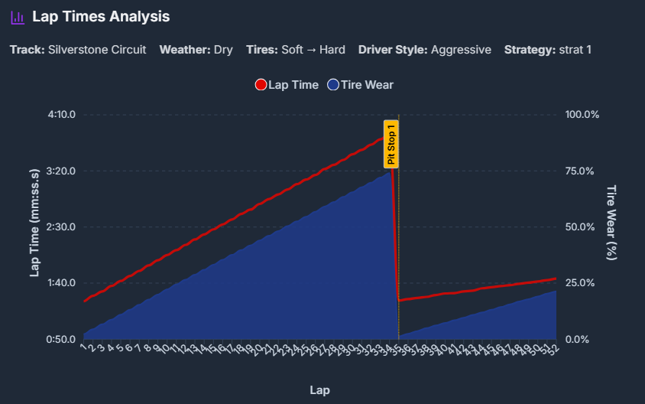
Advantages:
- Use of close to real-time weather for each individual lap
- Ability to set pit stop laps and available tyre compounds
- Huge variety of circuits (more than 30, with F1 and non F1 tracks)
Disadvantages:
- Limited weather customisation
(“weather conditions” is the only editable variable, whereas every other weather forecast related variable is either hardcoded or fetched live)
- Missing core variables such as degradation and grip level (per lap)
Identifying the users’ needs
To get an understanding of the factors I should keep in mind while making this simulator, I conducted a survey that asked participants about some of the main parts of the simulator.
The survey included questions mainly about the users’ history of watching the sport, knowledge about the sport, and about the main expectations of this simulator
When asked about their knowledge of race strategies, most people turned out to have a basic understanding about it, while fewer people had an in depth understanding about it, or had no idea about it whatsoever.
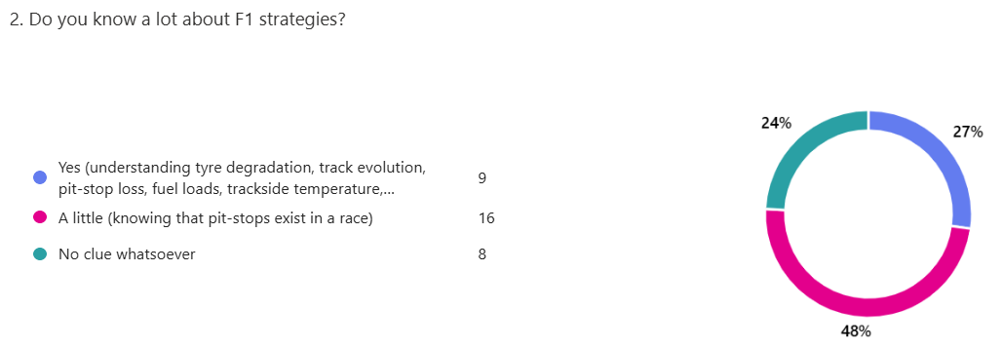
The most important thing(s) for this simulator, according to the responses, is having a good UI and being able to cleanly plot data. They were asked to pick 2 things that felt the most important to them, amongst the 3 given choices. As we can see, people give less emphasis on convenience of use.
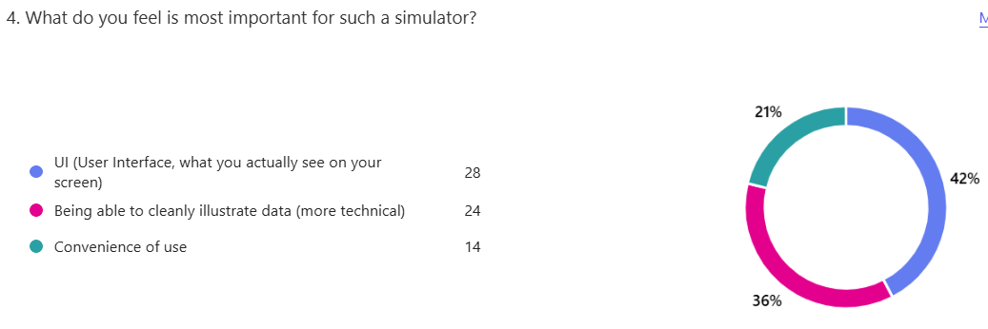
They also preferred a clean and minimal UI as opposed to a robust and data heavy one.
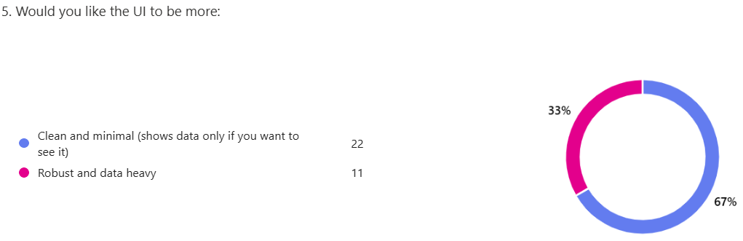
One of the questions in the survey asked the people about other supplementary features that the simulator should include, such as a tutorial, and explanation of the working of the strategies during the actual race, most of the people responded with wanting both, when given the choice of either, neither, or both.
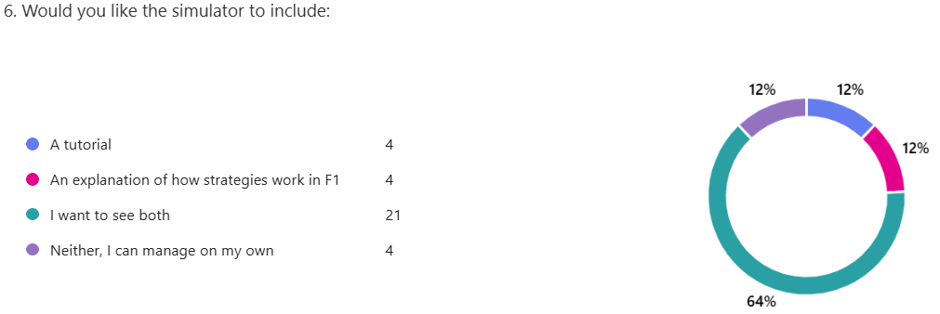
The next question asked the respondents about the post-race strategy analysis. It was about the usage of graphs to illustrate lap by lap degradation and effect on performance (yes/no), and about the simplicity of the actual analysis (if they wanted the analysis to be simpler and cleaner or more technical and data heavy). The respondents had to give 2 answers for this question.
Most of the respondents wanted the post-race analysis to make use of graphs, and have the option to choose between a simpler or more technical analysis.
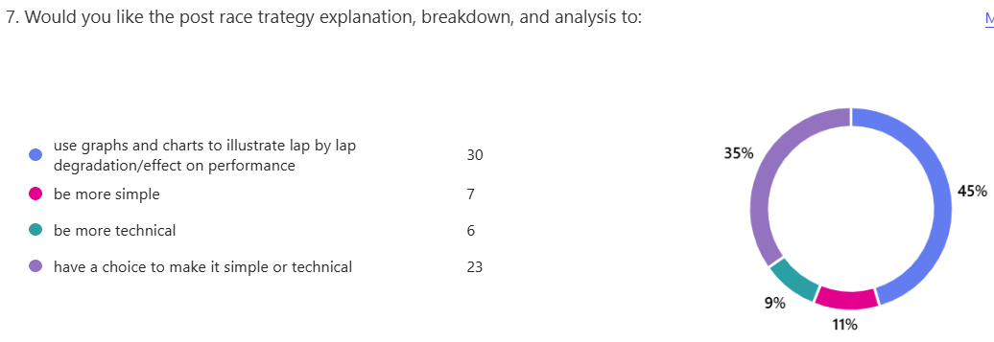
For track selection (number of choices), people were given the choice of (1-7), (8-15), or (16-24). Most of the people wanted a higher track selection, and ended up choosing (8-15) or (16-24) tracks.
(the maximum limit is 24 because that is the number of races per season)
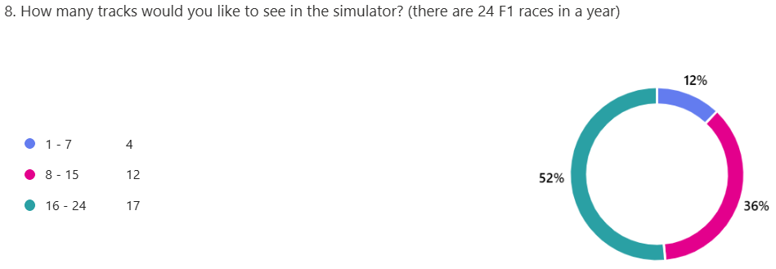
Analysing the responses
After looking at the responses in the survey, I can make a conclusion on what are the most important parts of the simulator and how it should be built.
Question 2: Most of the people have a basic understanding about F1 strategies, while only a few know it in detail or have no knowledge about it at all. From this, we can conclude that the simulator must be advanced, but beginner friendly at the same time.
Question 4: According to the survey, the 2 most important things for the users when using the simulator are the UI and cleanly illustrating data (even though the convenience of use is the least picked option, it will be given a lot of importance).
Question 5: Most of the people prefer a clean and minimal UI as opposed to a more robust and data heavy UI. Thus, we can keep the UI simple and save the complexity for the actual post-race analysis.
Question 6: Most of the people want to see a tutorial and an explanation of how the actual strategies work. These features can be implemented in the actual simulator.
Question 7: Most of the people want the illustrations to be done using graphs and charts in the post-race analysis, and want to have the choice of being presented a simple or more technical analysis.
Question 8: As for the number of circuits, most of the responses were for a greater track selection. (36% of the total responses was for 8 - 15 tracks and 52% of the responses was for 16 – 24 tracks)
Proposed objectives (simulator layers)
The main objective for the simulator is to model, analyse, and optimise F1 race strategies using modelling, under deterministic and probabilistic conditions.
1. (Layer 1) To be able to fully develop a ML model for lap time, using core variables that include: tyre degradation and health/status, track evolution/grip level, pit-stop loss, and fuel loads. It should be able to produce a lap time, for one single lap, using all these relevant variables. (trained with historical data)
2. (Layer 2) To be able to take input constraints of the tyre compounds available and the number of mandatory pitstops if applicable (Monaco, Qatar), create a single strategy, simulate a full race based off that strategy, and output a total race time.
3. (Layer 3) To be able to determine the most optimal strategy by generating, simulating, and comparing multiple strategies (under deterministic conditions), and coming up with the single best strategy for a race with pre-determined events. (best case optimisation)
4. (Separate) To be able to evaluate strategies under uncertainty (Monte Carlo) and identify the most robust strategy, with a similar process of generating, simulating, and comparing multiple strategies, with the introduction of a new random event generation layer. (risk-aware optimisation)
Proposed objectives (general)
Main UI:
- The main menu should have “Play Tutorial”, “About F1 Strategies” “Custom Simulation” and “Monte Carlo Simulation” options.
- Each option should take the user to a new window.
- If the user is on the main window, pressing the escape key should close the application, and for any other window, close that window and bring the user back to the main menu
- (the UI should be simple to use)
Simulation (deterministic):
The user should be able to select 1 of 24 available tracks and give input constraints such as available tyre compounds, safety car laps, mandatory pit stops (if applicable), and the tyre degradation status.
Simulation (probabilistic):
- Similarly, the user should be able to select 1 of 24 available tracks and give input constraints, such as available tyre compounds, mandatory pit stops, and tyre degradation status.
- The user will not be able to input safety car laps, and a clear explanation must be provided as to why they cannot do that (explanation of how the simulated safety car events are random)
Post-race analysis:
- The user should be able to choose between a simple or detailed post-race analysis.
- The analysis should include graphs of lap times, tyre wear and health (both as percentages), difference in current and base lap time (also known as positive / negative delta)
- The analysis should also include a description of stint tyres, stint length, and the stop strategy used.
(Example description):
Strategy: 2 stop strategy
Stint tyres: Soft --> Medium --> Soft
Stint lengths: 15 Laps --> 30 Laps --> 13 Laps
(this is not an exact replica, but the description should be similar to it)
- For deterministic conditions, the pit stop laps and safety car led laps should be highlighted in the graphs
- For probabilistic conditions, the pit stop laps and safety car led laps should be highlighted in the graphs, but an explanation but be provided as to how they will almost always differ from what is show. A similar explanation should be provided for the description of stint tyres, stint length, and strategy being used
- For probabilistic conditions, an explanation of why the judgement criteria for strategies is robustness and not speed must be given.
Acceptable limitations:
Limited scope of race factors:
The simulator only considers 5 main factors: tyre degradation, fuel load, track evolution, pit stop loss, and safety cars. Undercutting / Overcutting are removed as the strategy is for a single car.
Fixed race format:
The race length is fixed (the same as what it is in real life) and there are no dynamic race changes, such as red flags and restarts. This has been done to keep all simulations consistent and comparable with one another
Discrete strategy space:
Strategy categories are of a limited number, i.e. 1 stop, 2 stops, or 3 stops. This has been done to keep the simulator as realistic as possible and optimisation manageable. (this should not be a huge problem as this is exactly how normal strategies would be in real life under normal conditions)
Limited randomness:
In the probabilistic (Monte Carlo) mode, the only events that are random are safety car events, where all other variables remain fixed. This has been done to keep the uncertainty controlled and interpretable
Predefined environmental conditions:
The environmental effects are limited to degradation scenarios (low, medium, or high), with no real time external data inputs. This is because using live weather data alongside historically averaged models for track evolution and fuel load creates a lot of inconsistency, since the weather represents real-time conditions whereas the other variables represent averaged behaviour.
Computational constraints:
The number of probabilistic (Monte Carlo) simulations will be limited to about 1000 runs. The total number of strategies will also be reduced (compared to deterministic simulations) to ensure a reasonable runtime and performance.
Initial Modelling
Simplified initial modelling (deterministic simulations):
For deterministic simulations, the process involves 4 main parts, which is the random strategy generator, the optimiser, the simulator, and the lap model.
- Lap Model – the actual ML model that calculates the lap time for one single lap
- Simulator – the simulation engine, that simulates a single race, with the strategy generated by the strategy generator, using the lap model for each lap of the race, and summing up the time taken for that single strategy.
- Strategy Generator – the random strategy generator, that generates all legal strategies (accounting for the 2 strategy-related user inputs)
- Optimiser – the optimiser that evaluates the performance of all the generated strategies against the actual race simulation (specifically finding the fastest strategy)
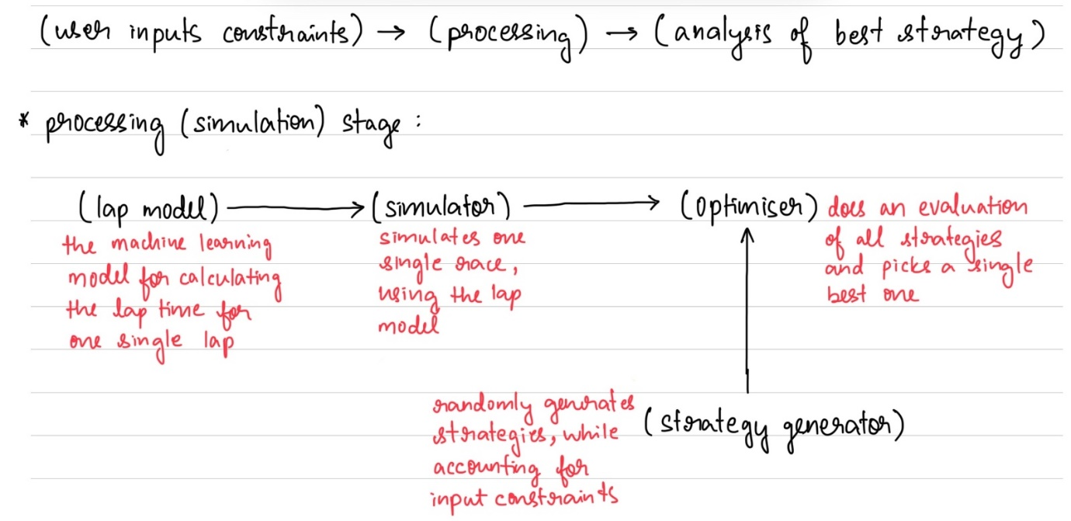
Simplified initial modelling (probabilistic simulations)
For probabilistic simulations, the process involves 5 parts (4 of the parts are the same, but there is an introduction of stochastic simulation layer). The 5 parts include the optimiser, the random strategy generator, the simulator, the lap model, and the stochastic simulation (monte carlo) engine.
- Lap Model – the actual ML model that calculates the lap time for one single lap
- Simulator - the simulation engine, that simulates a single race, with the strategy generated by the strategy generator, using the lap model for each lap of the race, and summing up the time taken for that single strategy.
- Strategy Generator – the random strategy generator, that generates all legal strategies (accounting for the 2 strategy-related user inputs)
(up until this point, these parts are common to deterministic and probabilistic simulations)
- Stochastic simulation engine – the engine that runs the same strategy multiple times, under randomly generated safety car scenarios (the randomness being the lap on which the safety cars starts and the actual number of laps for which it stays out). Once the simulations have been carried out, it gives each strategy a single score in terms of robustness and reliability.
- Optimiser – the optimiser that evaluates the performance of all the generated strategies (finding the most robust and reliable strategy instead of the fastest one)
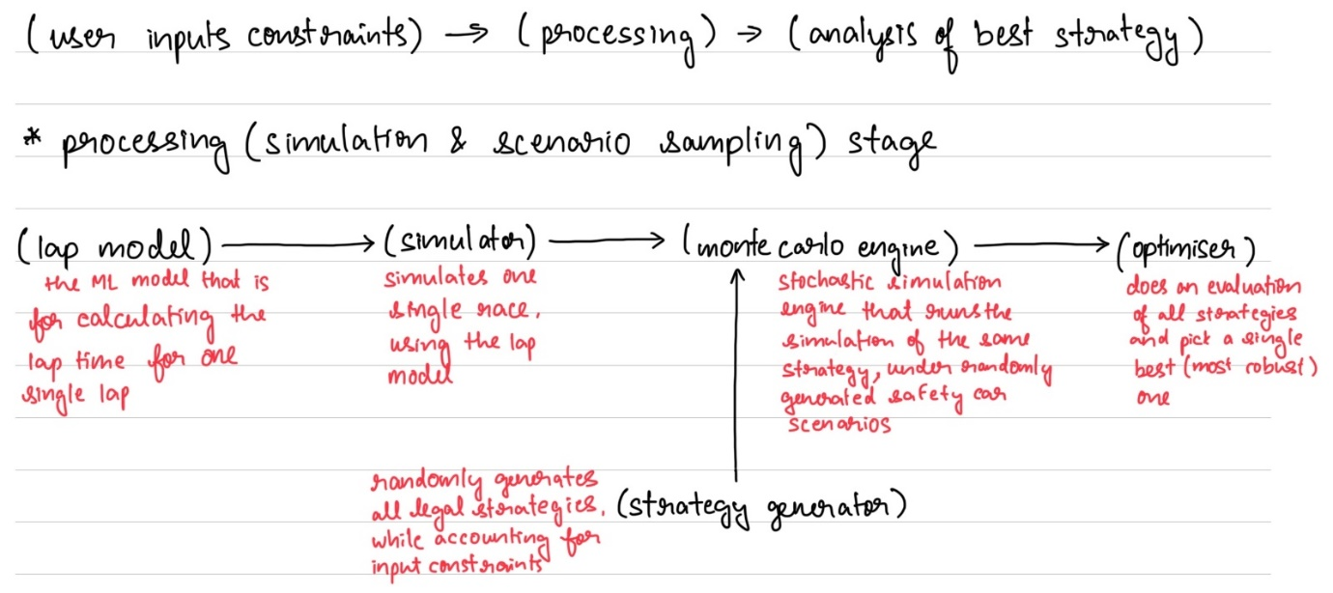
Comparison metrics for probabilistic simulations
The actual “robustness” and “reliability” of a single strategy is based off 4 mathematical factors.
- Mean race time (as the main baseline):
(where N is the total number of simulations, and T_{i} is the time taken for the i^{th} simulation)
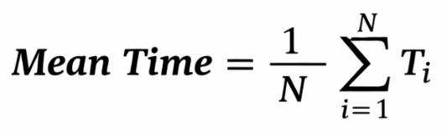
- Win rate (for decision reliability):
Even though the simulations are carried out sequentially (the same strategy is used for repeated simulations under random events), the strategies will be compared with each other as they are being simulated under the same random events (the random events are generated all at once instead of being generated individually for each strategy, this is to keep comparisons consistent, by seeing how different strategies would work out under the same randomness and uncertainty)
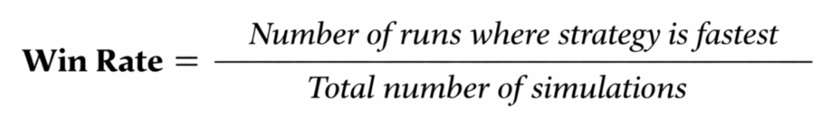
- Standard deviation (to measure variance)
Computed only after all the simulations for one strategy have been carried out since a mean value is needed first
(where N is the total number of simulations T_{i} is the time taken for the i^{th}
simulation, and Mean is the mean time of all simulations)


